
Touchstones
Netcards

Consolation & Desolation Netcards with Text

Artist HRJ
Ballet HRJ
Blue HRJ
Boxing HRJ



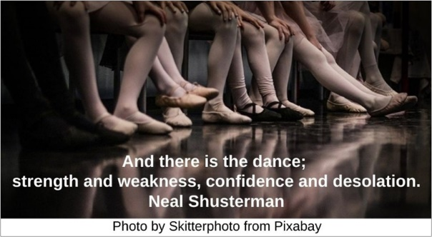

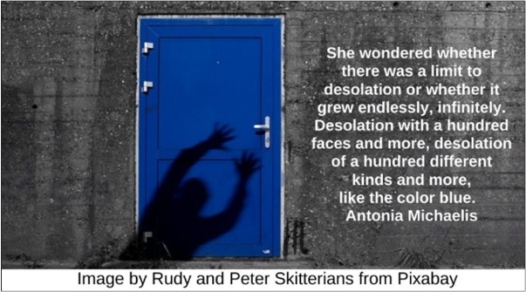



Desolate Landscape HRJ
Desolation HRJ
Diamond HRJ
Don’t Be Afraid HRJ



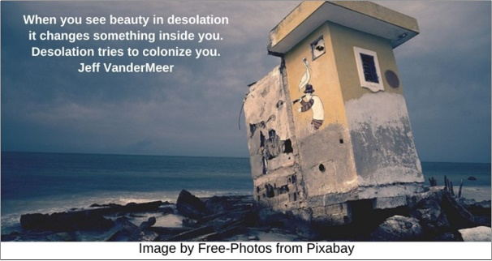

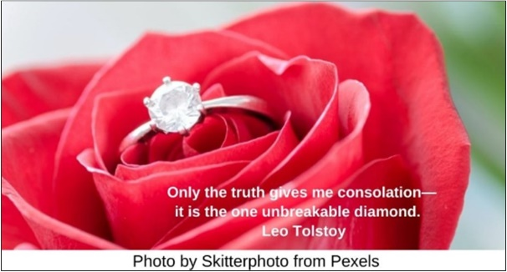

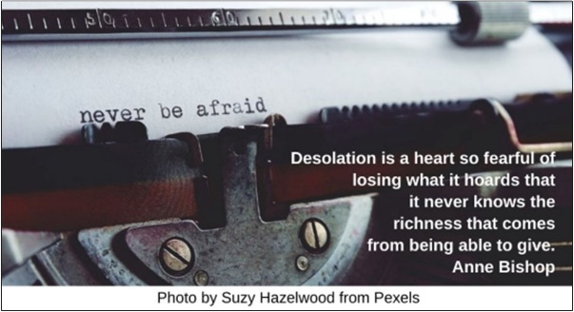

Door HRJ
Ecstasy HRJ
Fear HRJ
Future HRJ

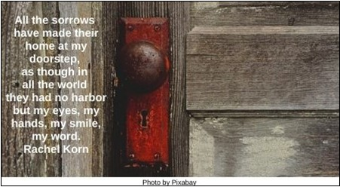

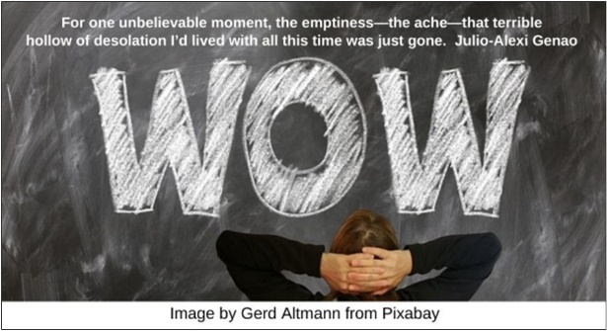

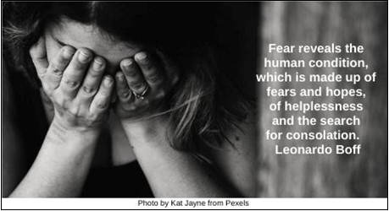



Hand on Heart HRJ
Hopeless HRJ
Hunger HRJ
Imaginary HRJ

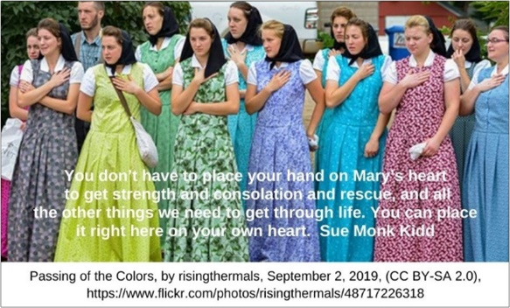

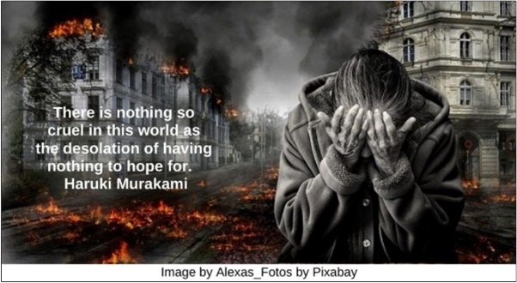

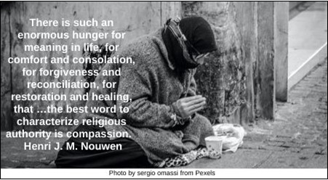



Joy HRJ (duplicate quote for Rainbow)
Kindness HRJ
Lost HRJ
Memory HRJ

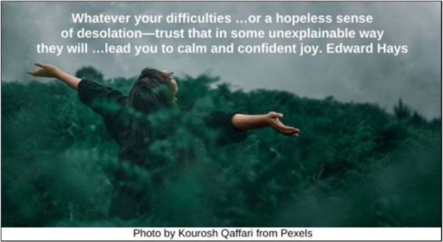

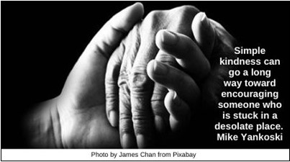





Misery HRJ
Rainbow HRJ (duplicate quote for Joy)
Smile HRJ
Snowy Landscape HRJ

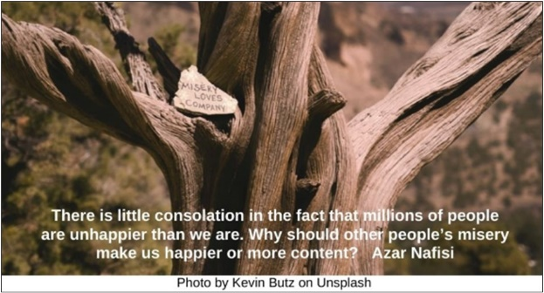

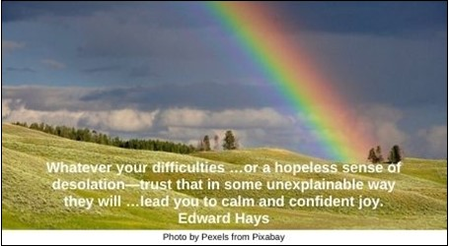

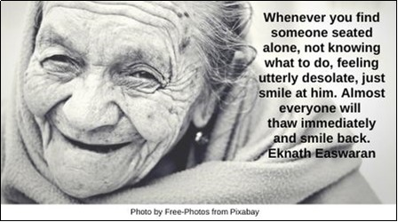

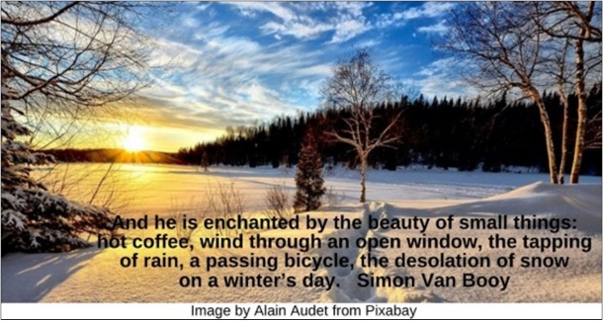

Socrates HRJ
Sunrise HRJ
Talking HRJ
Tears HRJ

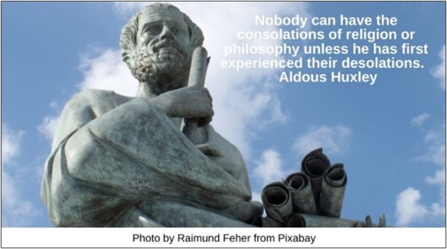

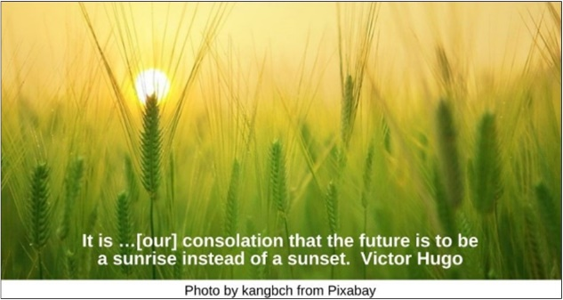



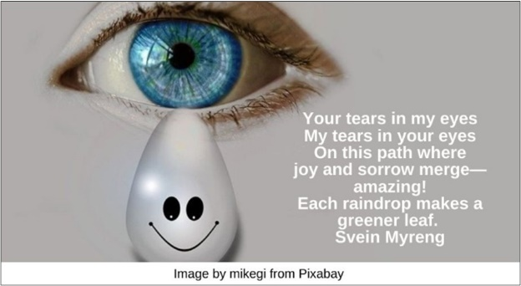

Telescope HRJ
War HRJ
Window HRJ
World Desolation HRJ



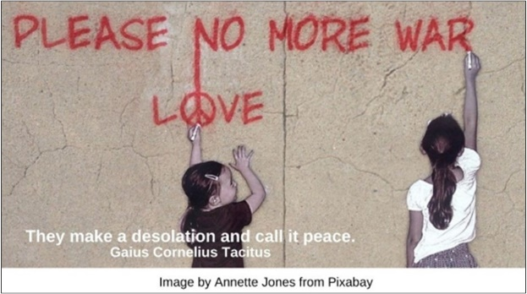

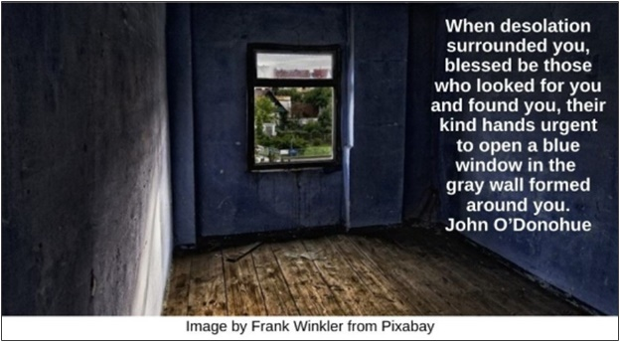



Text of Quotes
Artist HRJ
There is a great consolation in simply doing something you love. Jojo Moyes

Ballet HRJ
And there is the dance; strength and weakness, confidence and desolation. Neal Shusterman

Blue HRJ
She wondered whether there was a limit to desolation or whether it grew endlessly, infinitely. Desolation with a hundred faces and more, desolation of a hundred different kinds and more, like the color blue. Antonia Michaelis

Boxing HRJ
That …week …was a consolation, a pure relief. The world will give you that once in a while, a brief time out; …you go to your corner, where somebody dabs mercy on your beat-up life. Sue Monk Kidd

Desolate landscape HRJ
How desolate the landscape can be / between the regions of kindness. Naomi Shihab Nye

Desolation HRJ
When you see beauty in desolation it changes something inside you. Desolation tries to colonize you. Jeff VanderMeer

Diamond HRJ
Only the truth gives me consolation—it is the one unbreakable diamond. Leo Tolstoy

Don’t Be Afraid HRJ
Desolation is a heart so fearful of losing what it hoards that it never knows the richness that comes from being able to give. Anne Bishop

Door HRJ
All the sorrows have made their home at my doorstep, as though in all the world they had no harbor but my eyes, my hands, my smile, my word. Rachel Korn

Ecstasy HRJ
For one unbelievable moment, the emptiness—the ache—that terrible hollow of desolation I’d lived with all this time was just—gone. Julio-Alexi Genao

Fear HRJ
Fear reveals the human condition, which is made up of fears and hopes, of helplessness and the search for consolation. Leonardo Boff

Future HRJ
You know what I dislike? When people use the future as a consolation for the present. I don’t know if there is anything less helpful. Stephanie Danler

Hand on Heart HRJ
You don’t have to place your hand on Mary’s heart to get strength and consolation and rescue, and all the other things we need to get through life. You can place it right here on your own heart. Your own heart. Sue Monk Kidd

Hopeless HRJ
There is nothing so cruel in this world as the desolation of having nothing to hope for. Haruki Murakami

Hunger HRJ
There is such an enormous hunger for meaning in life, for comfort and consolation, for forgiveness and reconciliation, for restoration and healing, that …the best word to characterize religious authority is compassion. Henri J. M. Nouwen

Imaginary HRJ
The consolation of imaginary things is not imaginary consolation. Roger Scruton

Joy (duplicate quote with Rainbow) HRJ
“Whatever your difficulties …or a hopeless sense of desolation—trust that in some unexplainable way they will …lead you to calm and confident joy.” Edward Hays

Kindness HRJ
Simple kindness can go a long way toward encouraging someone who is stuck in a desolate place. Mike Yankoski

Lost HRJ
“It might be well enough to wander if you’ve a place and people to come back to, but I tell you now there’s no desolation like wanting to go home and truly not knowing where it is.” Elizabeth Kerner

Memory HRJ
We build ourselves with memory and console ourselves with memory. Laurent Binet

Misery HRJ
There is little consolation in the fact that millions of people are unhappier than we are. Why should other people’s misery make us happier or more content? Azar Nafisi

Rainbow (Duplicate quote with joy) HRJ
Whatever your difficulties …or a hopeless sense of desolation—trust that in some unexplainable way they will …lead you to calm and confident joy. Edward Hays

Smile HRJ
Whenever you find someone seated alone, not knowing what to do, feeling utterly desolate, just smile at him. Almost everyone will thaw immediately and smile back. Eknath Easwaran

Snowy Landscape HRJ
And he is enchanted by the beauty of small things: hot coffee, wind through an open window, the tapping of rain, a passing bicycle, the desolation of snow on a winter’s day. Simon Van Booy

Socrates HRJ
Nobody can have the consolations of religion or philosophy unless he has first experienced their desolations. Aldous Huxley

Sunrise HRJ
It is …[our] consolation that the future is to be a sunrise instead of a sunset. Victor Hugo

Talking HRJ
If we use language that does not hurt people but that affirms people, we will lead people to greater peace, happiness, hope, and consolation. John Dear

Tears HRJ
Your tears in my eyes
My tears in your eyes
On this path where
joy and sorrow merge—
amazing!
Each raindrop makes a
greener leaf.

Telescope HRJ
What do I believe in? Imagination, gardens, science, poetry, love, and a variety of nonviolent consolations. Teju Cole

War HRJ
They make a desolation and call it peace. Gaius Cornelius Tacitus
Image by Annette Jones from Pixabay

Window HRJ
When desolation surrounded you, blessed be those who looked for you and found you, their kind hands urgent to open a blue window in the gray wall formed around you. John O’Donohue

World Desolation HRJ
When I am battered and oppressed by the world that humanity has made—which is different from the world that is was given—my primary defense, my consolation, is the absurdity of that world. Dean Koontz

